**MD PSP (Pesticide Stewardship Partnership): Mtg 4**

February 19, 2025; Wednesday, 9-11am

COAREC (“Experiment Station”): 850 NW Dogwood Ln, Madras

<https://zoom.us/j/3103247170?pwd=bnpsVUFnbngwaThNaWEvYkdzQW1wUT09>

Meeting ID: 310 324 7170 Passcode: 952210

One tap mobile:  [+13462487799,,3103247170#,,,,*952210#](http://+13462487799,,3103247170/#,,,,*952210)

***Group Mission****: 1) Increase knowledge of barriers to implementing BMPs, 2) develop communication material to increase understanding of MD PSP goal objectives and IPM, 3) develop a unifying campaign to reduce pesticides in MD waterways.*

**PSP Objectives, set by the PSP in 2023: By December 2028,**

1. All 2024 Pesticides of Concern (POC) are below aquatic life benchmarks
   1. Currently below: Dimethoate, Prometryn & Sulfometuron methyl
   2. Barely above: Diuron & Oxyfluorfen
   3. Above: Imidacloprid & Linuron
2. Reduce detection frequency by 25% of the four highest detected pesticides of 2023.
   1. AMPA and Glyphosate are the highest (73 and 58%, respectively). However, they are not High POCs, which is not what the PSP is focusing on.
   2. The MDPSP will focus on the High POCs with the highest detection frequencies: Diuron (55%🡪41%), Linuron (48%🡪36%), Prometryn (40%🡪30,)
3. Reduce the # of High POCs to <3.

***Role of Group****: develop and implement an outreach plan to meet PSP objectives*

**Members**: Albert Sikkens (Pratum), Brad Klann (producer), David Gruen (DEQ), Drake Gilbert/Shilah Olson (Wasco SWCD), Jay McCabe (Wilbur-Ellis), Floyid Nelson/Jeremiah Dung/Steve Colman (COAREC), John Spring (COSI), Kathryn Rifenburg (ODA), Lane Springer (NUID), Lloyd Forman (producer), Mandy Ondrick (DEQ), Mark Wunsch (producer/County Commission), Rob Galyen (producer), Scott Simmons (Helena), Scotty Samsel (producer), Ellen Hammond/Ryan Brunner (SWCD)

**9:00 Introductions**:

**9:10 2024 Data and discussion (David Gruen)**

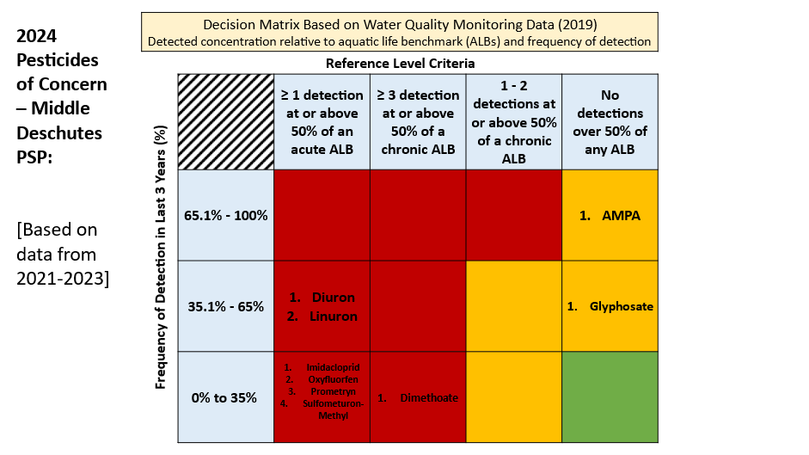**9:50 Required by PSP Grant and Strategic Plan**

* *Strategy 1: Establish formalized partnership initiative (a shared vision) onto which partners can sign (non-profits, businesses, municipalities, private landowners, etc)*
* *Metric 1: Sign 10 entities onto the formalized partnership initiative (a shared vision). Provide annual updates to formal partners through an annual meeting.*
* *Draft Vision: Pesticides are not detected in waterways*. But, what about glyphosate and 2,4-D?

**10:15 2024 Outreach: Needed by 2025 per Strategic Plan**

* Trifold (100 printed); distributed to Ryan Brunner, NUID, Pratum, W-E, Helena
* *Metric 1b: Develop material for BMPs for 6 target groups based on crops grown (bluegrass seed, carrot seed, and hay), irrigation practice applied (sprinkler, and furrow irrigation), or pesticide used (those listed as High Pesticides of Concern).*

**10:30 2025-27 PSP Grant**

* Due April 4
* 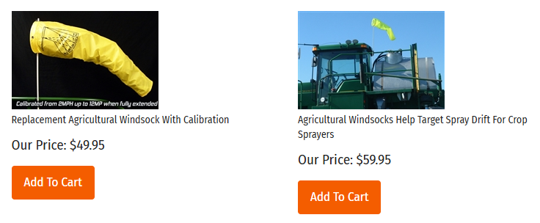“The PSP is not a monitoring program. The purpose of the water quality sampling is to find areas where outreach, education, and technical assistance can be created to reduce pesticide detection frequencies and concentrations in local waterways. If a location has been sampled for several years and no notable detections have been found then that sampling location needs to be moved to a new area”
* What to include?
  + Monitoring same sites and frequency?
  + Outreach
    - Windsocks
    - Posters
    - 1-on-1s with landowners/applicators
    - Neighbor workshops
    - A table of numbers and words

      Description automatically generated with medium confidenceReplacement part reimbursement

**10:55 Next meeting**